**Website for study:**

[**https://www.guru99.com/selenium-tutorial.html**](https://www.guru99.com/selenium-tutorial.html)

**Selenium webdriver:**

it is not a tool

it is web driver API

it is collection of Jars file. this files contain packages , classes, functions, interfaces.

**Setup selenium:**

https://www.youtube.com/watch?v=IkK7bS6hLms

**setup chomedriver:**

https://www.youtube.com/watch?v=FSetmugrnmY

**chrome driver:**

https://chromedriver.storage.googleapis.com/index.html?path=114.0.5735.90/

**firefox driver:**

https://www.youtube.com/watch?v=avr68JmDLJQ

**Demo webSite for test:**

<https://demo.guru99.com/test/newtours/>

**Selenium library (Jars) setup in eclipse project:**

1. Create simple java project > Right click on java project > properties > select java build path > click on libraries > select class path(don’t select modulepath) > add external jars > select from selenium folder.

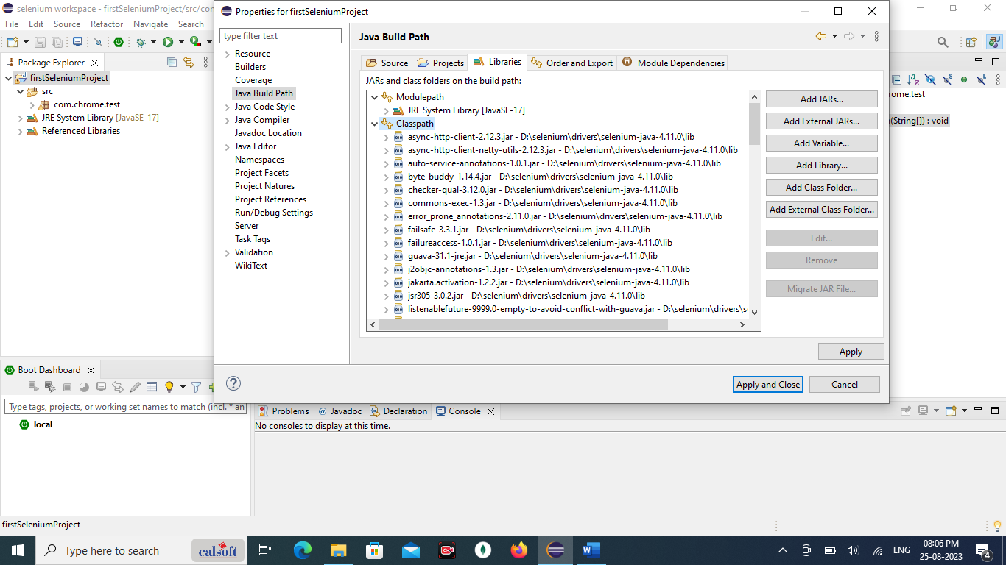

**List of websites to practice selenium:**

* **Cleartrip:** [**https://www.cleartrip.com/**](https://www.cleartrip.com/)
* **https://opensource-demo.orangehrmlive.com/web/index.php/auth/login**
* [**http://the-internet.herokuapp.com/**](http://the-internet.herokuapp.com/?ref=hackernoon.com) - This is not a full-fledged website, but it offers components of the website that you can test. If you are working on practicing a complex component, I would recommend this site.
* [**https://www.saucedemo.com/**](https://www.saucedemo.com/?ref=hackernoon.com) - This is a demo website from SauceLabs. It’s a custom eCommerce site by SauceLabs. But, not with much functionality.
* [**https://ultimateqa.com/automation**](https://ultimateqa.com/automation?ref=hackernoon.com) - This is also a good site. But, it does not have a complete user journey. If you want to practice just a part of a user journey, this is a good site.
* [**http://opensource-demo.orangehrmlive.com**](http://opensource-demo.orangehrmlive.com/?ref=hackernoon.com)**/** - This website is not meant to practice test automation. But, you can write a test around this.
* [**https://phptravels.org**](https://phptravels.org/?ref=hackernoon.com)**/** - Similarly, this website is not meant to practice. But, for a short time, you can write tests and execute them. Can't be used for demonstration as it may get changed anytime.
* [**https://demo.openmrs.org/openmrs**](https://demo.openmrs.org/openmrs?ref=hackernoon.com)**/** - This is another open-source site. But, can't expect to have it unchanged.

**Web Elements:** button, option, input box, submit, login ,checkbox, drop down box, images, list box, web table, drag and drop, calendar control, sate pickers, links, radio button, elements on website are considered as web elements.

(Everything on page considered as a web elements)

Check box : in check box we can select multiple option.

Radio button: only one we can select.

**Note**: selenium can not support window. Means while upload photo window is open to pick image. That window feature is not supported.

**Overcome**: to overcome above issue. We can use third party tool. i.e. Auto-IT

**Locators:** (we can say properties of web elements)

Every web elements has different properties like: name, id, cssSelector, xpath these are mainly known as locators.

(to identify the web elements available on web page. For that we use locators.)

1. **Name**
2. **Id**
3. **cssSelectors**
4. **xpath**
5. **class name**

**Test case:**

1. open browser
2. open website
3. enter username
4. enter password
5. submit
6. close

**Login details properties:**

1. **Username:**

**copy element :** <input type="text" name="userName" size="10">

**copy xpath:** /html/body/div[2]/table/tbody/tr/td[2]/table/tbody/tr[4]/td/table/tbody/tr/td[2]/table/tbody/tr[2]/td[3]/form/table/tbody/tr[4]/td/table/tbody/tr[2]/td[2]/input

1. **Password:**

**copy element:** <input type="password" name="password" size="10">

**copy xpath:** /html/body/div[2]/table/tbody/tr/td[2]/table/tbody/tr[4]/td/table/tbody/tr/td[2]/table/tbody/tr[2]/td[3]/form/table/tbody/tr[4]/td/table/tbody/tr[3]/td[2]

1. **Submit:**

**Copy elemts:** <input type="submit" name="submit" value="Submit" style="background-color: #FACB00;border: 1px solid black;font-family:MS Sans Serif;font-size:15px;">

**Copy xpath:** /html/body/div[2]/table/tbody/tr/td[2]/table/tbody/tr[4]/td/table/tbody/tr/td[2]/table/tbody/tr[2]/td[3]/form/table/tbody/tr[4]/td/table/tbody/tr[4]/td[2]/div/input

**Driver methods:**

1. **driver.findElement(By.name()).sendKeys();**

this methods for : text box / input box

1. **driver.findElement(By.name()).click();**

this methods for : radio button, check box, link.

1. **Driver.Close**

Close browser

1. **driver.manage().window().maximize();**

for maximize browser window

**HeadLess Browser:**

**Agenda: Topics**

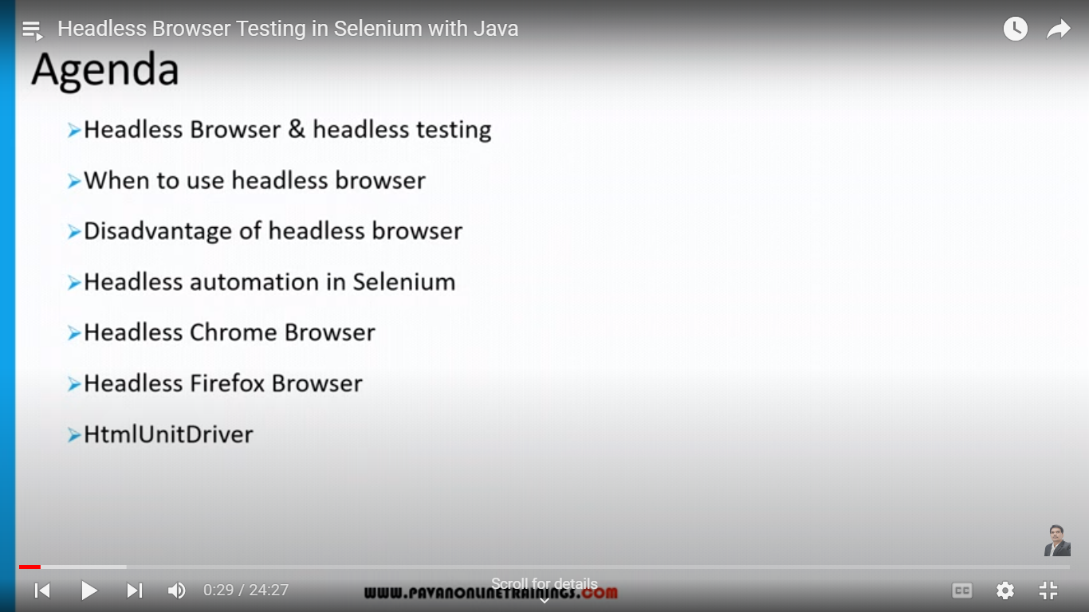

**What is headless browser?**

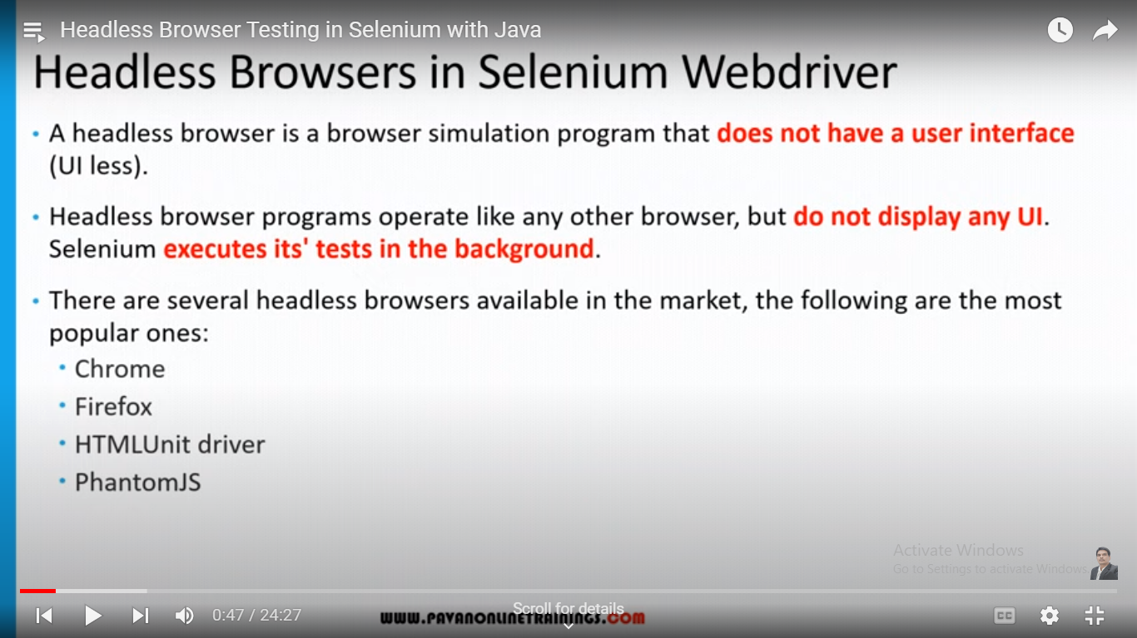

Browser does not have a user interface. Means it does not display any UI. Executes its tests in the background.

**What is headless browser testing?**

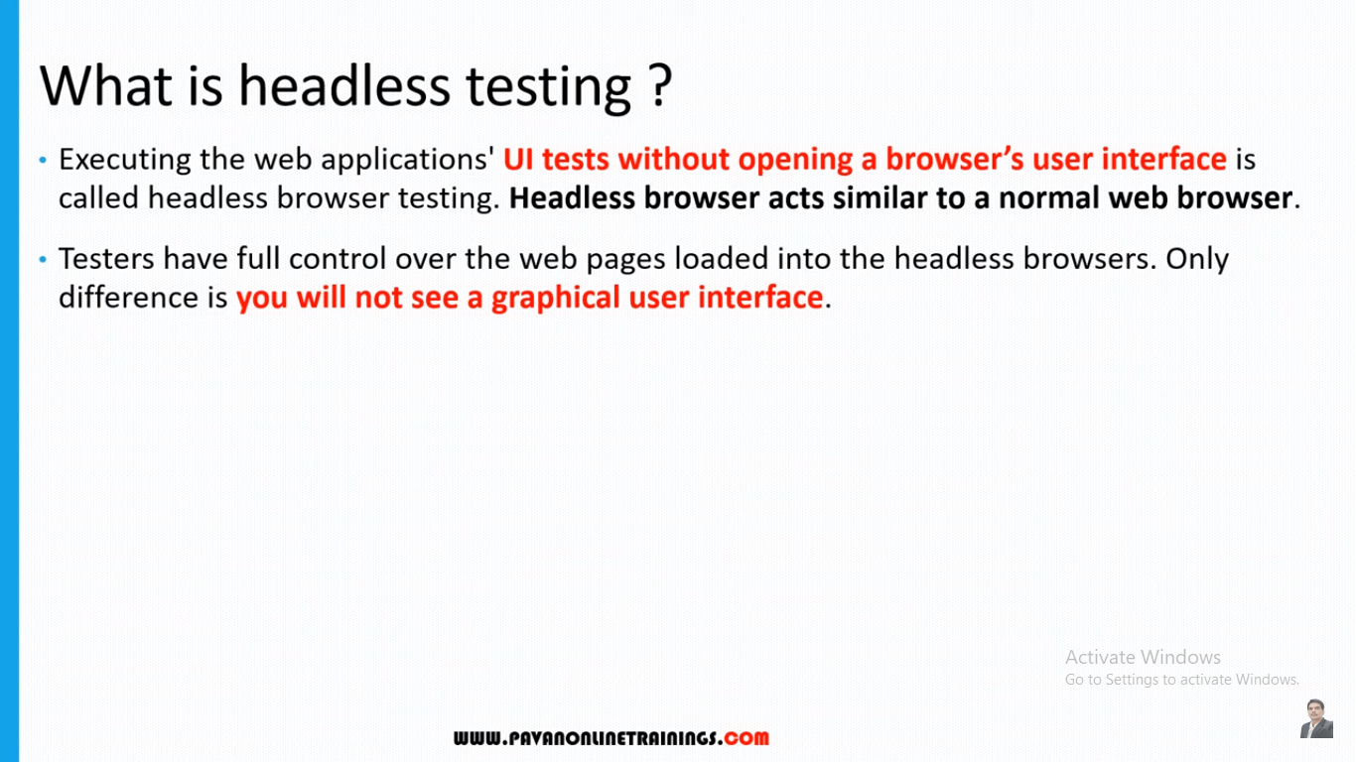

**When to use headless browser testing?**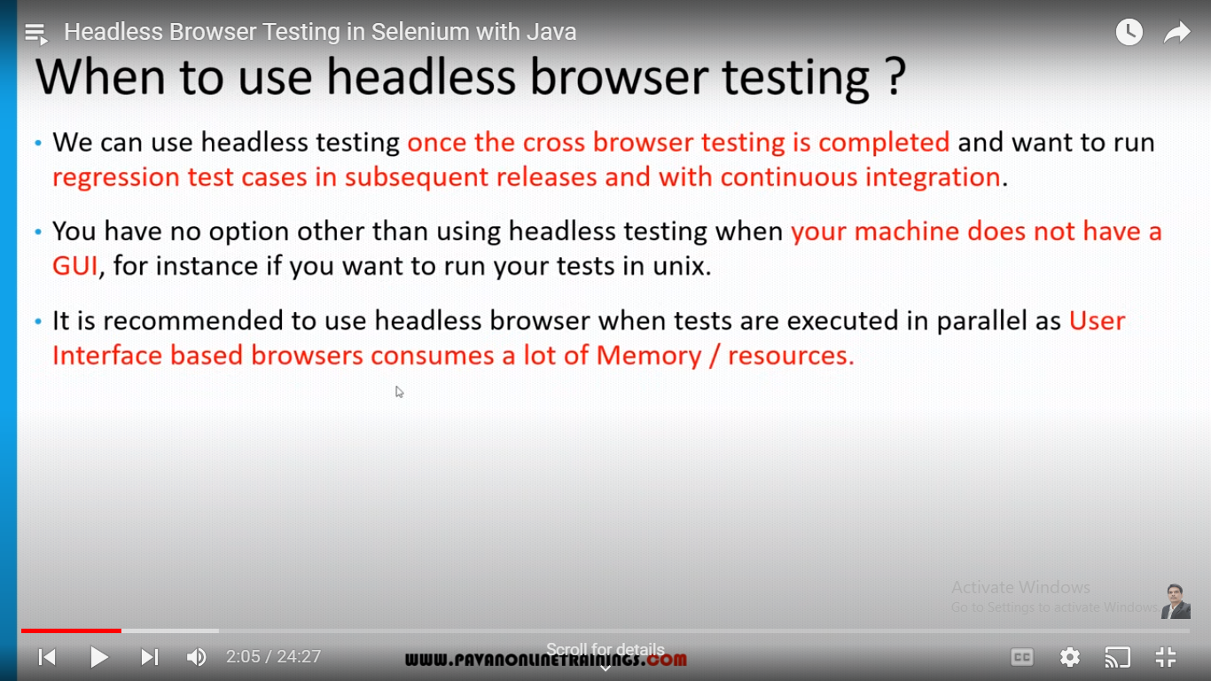

**Advantages of headless browser testing?**

Faster bcoz it doesn’t have UI

**Disadvantages of headless browser testing?**

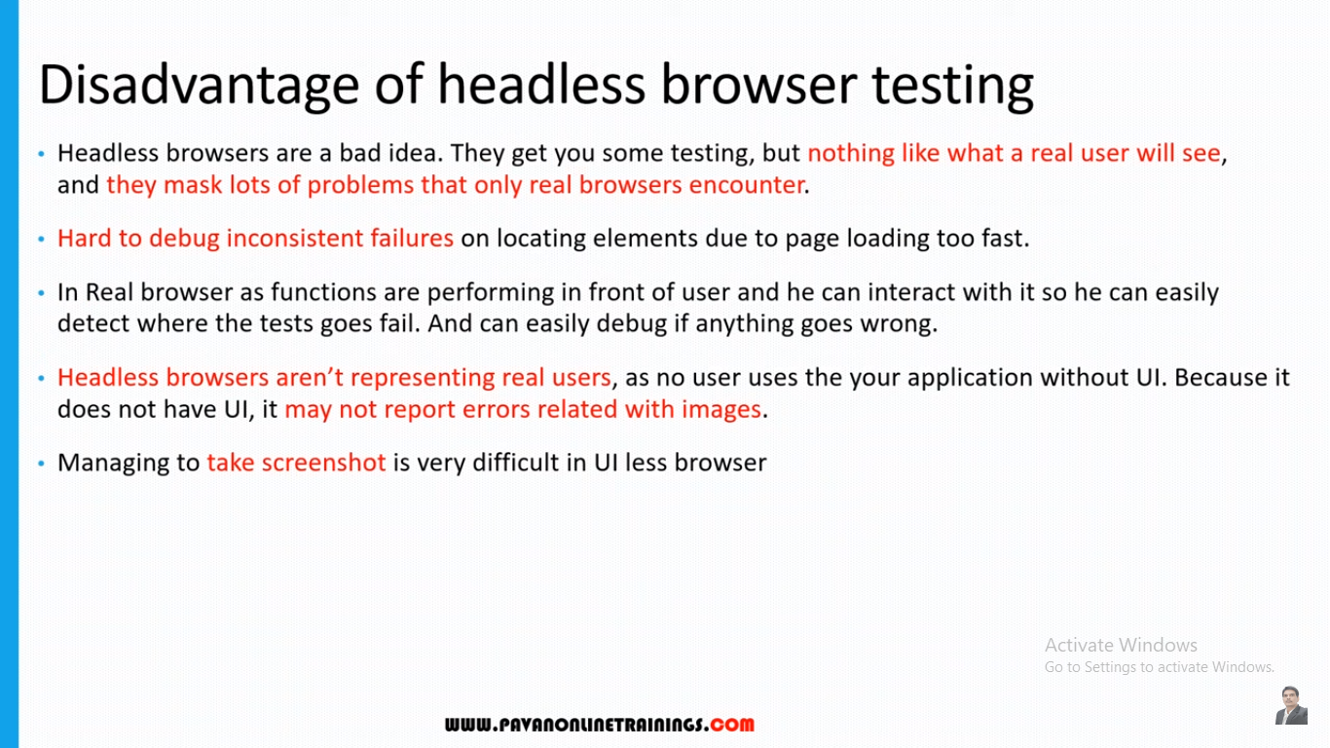

**Headless bowser automation in selenium?**

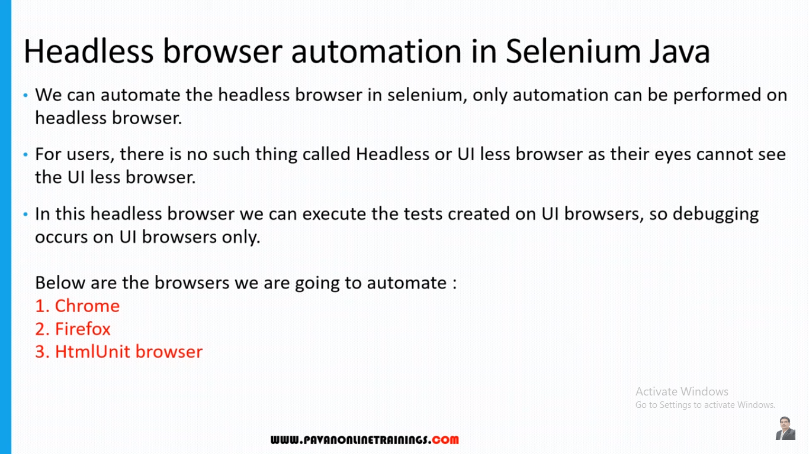

**Note: HtmlUnit browser has no UI. Key value settings are not required.**

**WebDriver commands(methods):**

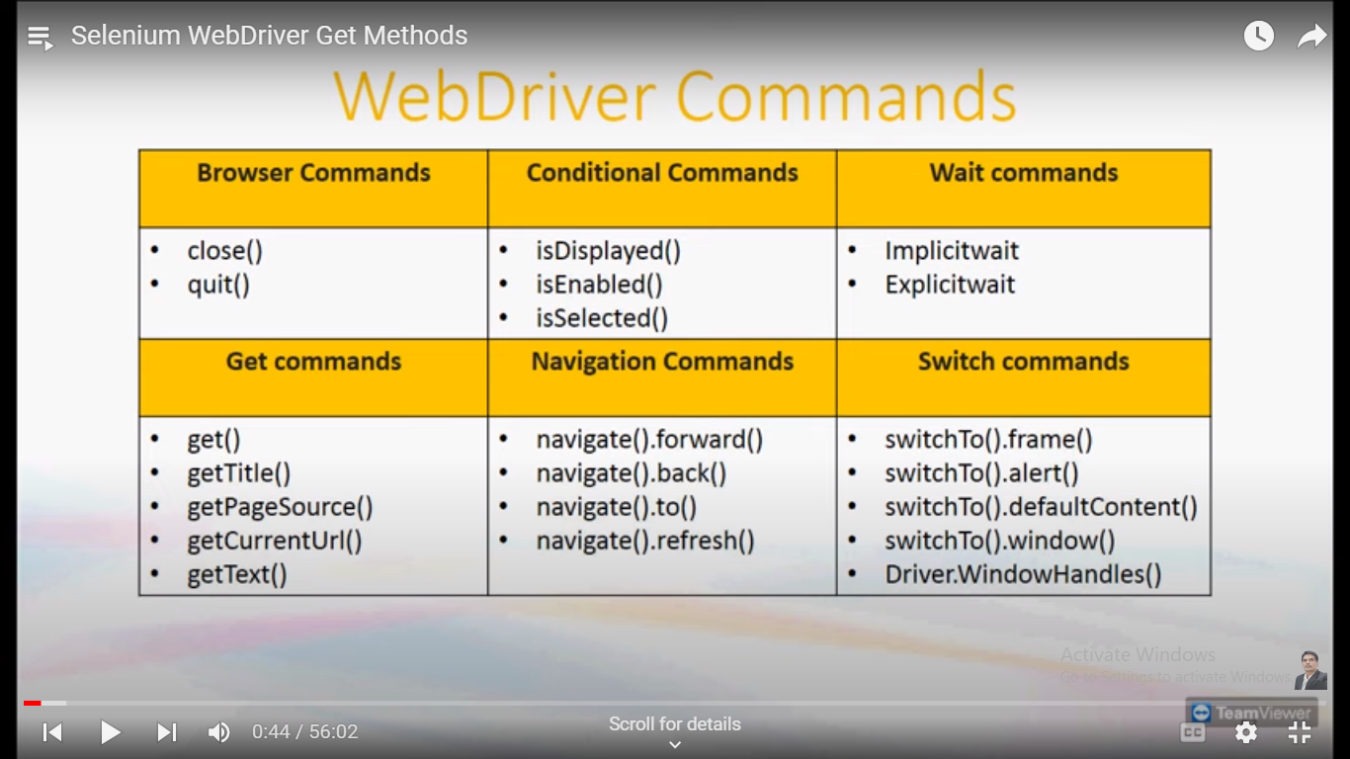

**Close vs quit:**

driver.close();// it will close one window/tab of browser

driver.quit();// it will close multiple windows of browser

**Navigate Commands:**

**1. driver.get()** => first open any url by using this method. eg. www.gmail.com

**2. navigate.To()** => replace gmail url with new url. eg. new url. www.facebook.com

**3. navigate.back()** => again u want to go back to gmail page, we use this method. it perform back arrow operation.

**4. navigate.forword()** => again u want to go facebook page. we use this method. it perform forward arrow operation.

**5. navigate.refresh()** => refresh the page.

**Conditional Commands:** this commands always returns true or false.

**isEnabled()** : used to verify status of text boxes. Some times text boxes are disabled, we cant enter any value.

**isDisplayed():** use to check particular web-element present on page or not.

If present return true. If not present return false.

**isSelected():** used for radio buttons or check boxes.

**Locators Part1:**  (locators are used to fine web elements on web page)

**Client:** whatever user can see that is basically client.

**3 tier application:**  
web server(UI), application server(backend), database server(db).

**Different types of Locators:**

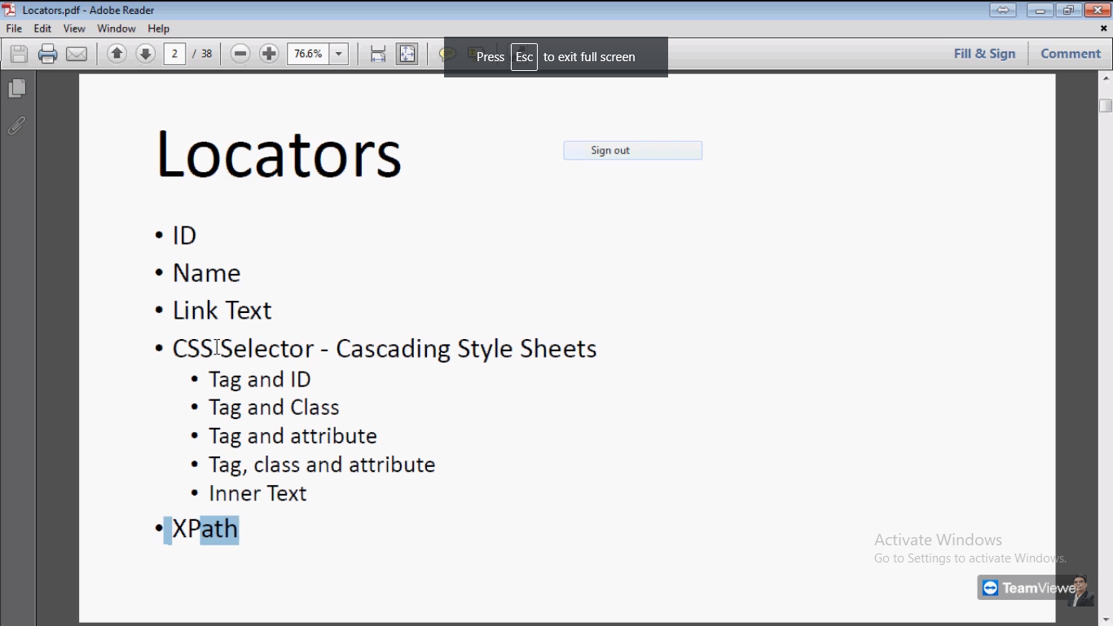

Mainly we use xpath locator.

**Selenium IDE:** it is a component of selenium. It is a plugin only for firefox browser.(record and playback). It cannot perform complex operation. It is simple type of recoder.

1. ID locator: driver.findElement(By.*id*("email")).sendKeys("digvijayptemp@gmail.com");
2. Name Locator:

driver.findElement(By.*name*("pass")).sendKeys("123456");

1. Link Text locator:

//link text used for only href link.

driver.findElement(By.*linkText*("Forgotten password?")).click();

1. Css selector combinations:

//in cssSelector diff combinations like:

Tag & id,

Tag & name

Tag & class,

Tag & attribute,

Tag & class & attribute

Inner text

// below we used tag & id here tag is "input" and id is "email"

use # between them

driver.findElement(By.*cssSelector*("input#email")).sendKeys("digvijay@gmail.com");

//tag & class here tag is "a" and class is "_97w5" use dot between them

driver.findElement(By.*cssSelector*("a._97w5")).click();

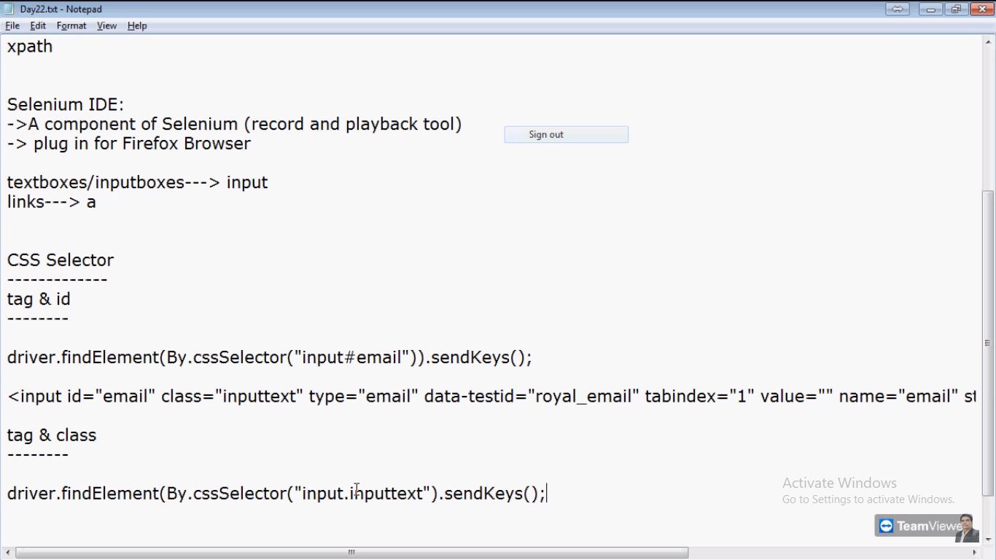

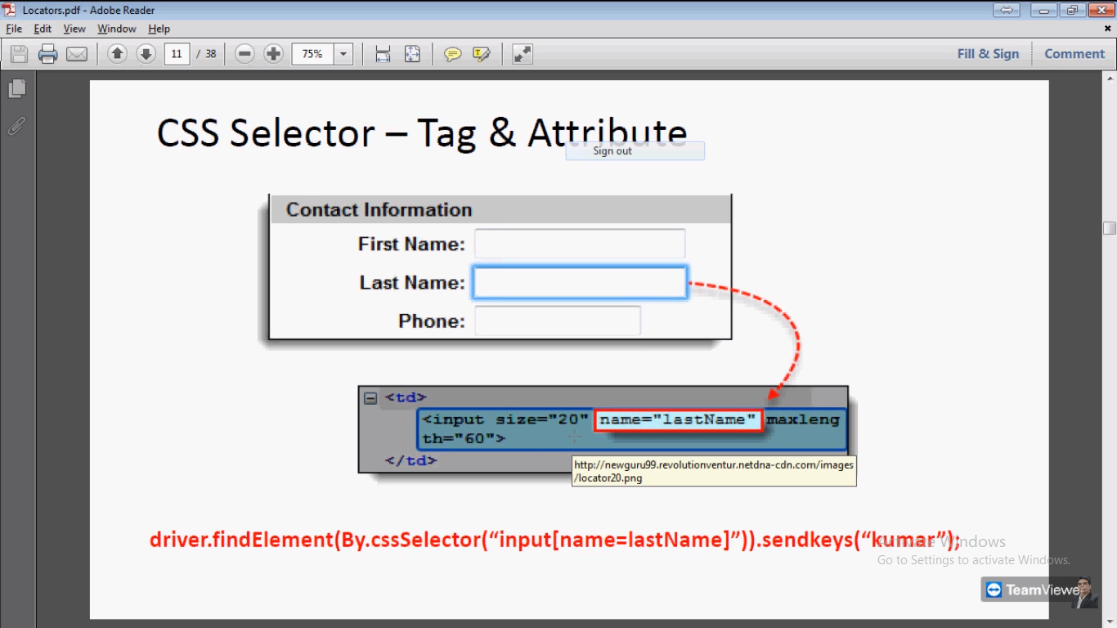

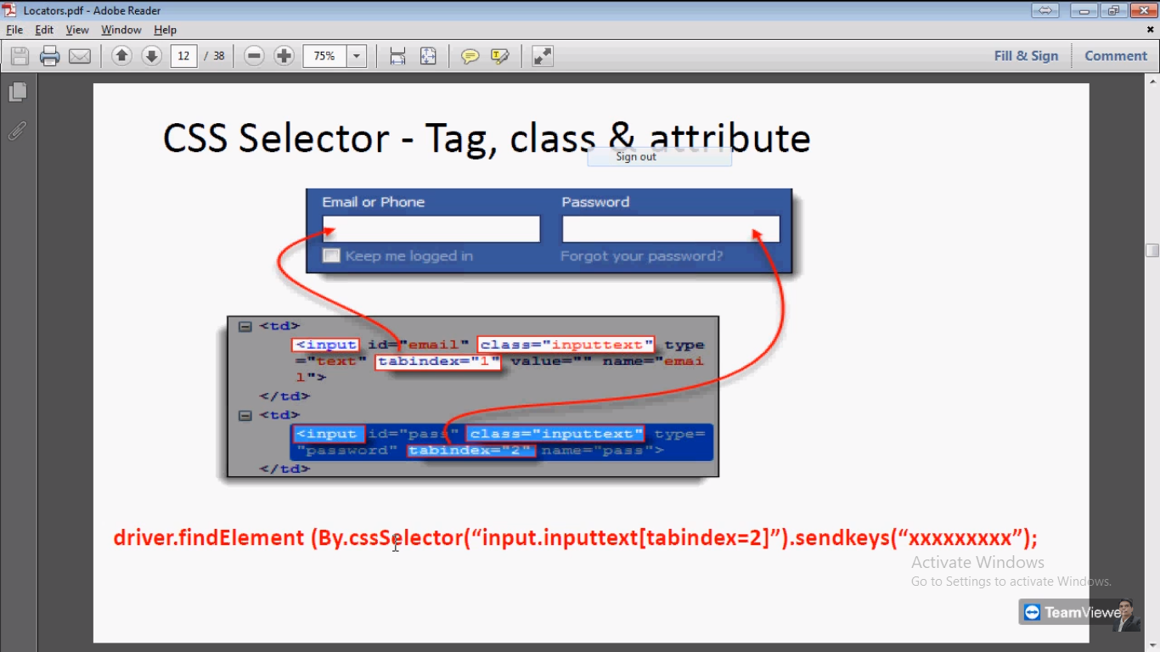

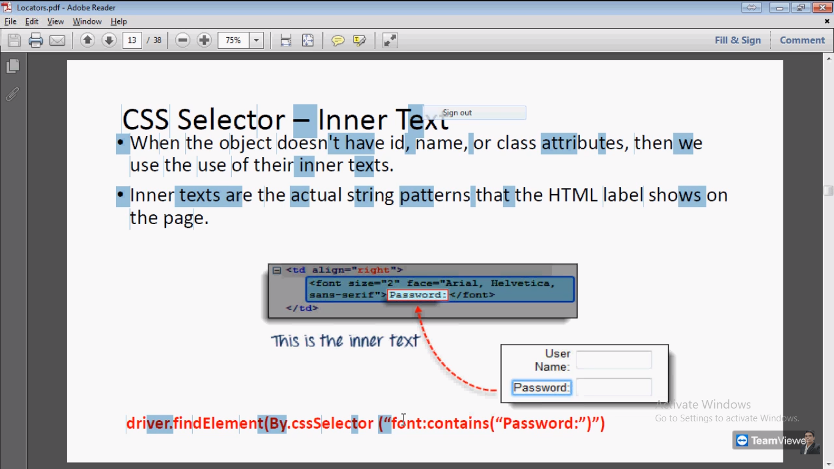

1. **Xpath locator:** this locator is very important and widely used.

It gives exact address of web elements on web page. As compared to others locators.

**Two types of xpaths are there:**  
1. Absolute Xpath: (chrome copy fullXpath)

* complete/full address of web element in the web page.
* In which we need to provide Entire path or entire address from source to destination this is called absolute Xpath.

**Eg.** Our home address > country> state>district> sub district> town> village

**Eg.** Html page there diff tags. <A tag > under <input tag > under another tag. Like wise

* [www.facebook.com](http://www.facebook.com)

1. copy full Xpath for email addres::  
   /html/body/div[1]/div[1]/div[1]/div/div/div/div[2]/div/div[1]/form/div[1]/div[1]/input

2. Relative Xpath: (chrome copy Xpath)

* Partial address of web elements in web page.
* no need to provide entire address from source to destination.
* We need to provide only whichever is familiar with surrounding of destination and then we need to provide destination.
* [www.facebook.com](http://www.facebook.com)

1. Only copy Xpath for email addres:  
   //*[@id="email"]

**How to differentiate Absolute Xpath and Relative Xpath:**

**Absolute Xpath:**

* /html/body/div[1]/div[1]/div[1]/div/div/div/div[2]/div/div[1]/form/div[1]/div[1]/input
* **In Absolute Xpath you will find multiple forward slashes (/) and all are single slashes**
* **Always start with single forward slash.**

**Relative Xpath:**

* //*[@id="email"]
* **Relative Xpath you will find double slash(//)**
* **Always starts with double forward slash.**
* **// * indicates that regular expression. this points to all tag names. means Skip all tags and comes to actual web element.**

**Which one is better to use?**

* We always prefer Relative Xpath.

**Why not better Absolute path?**

* /**html**/body/div[1]/div[1]/div[1]/div/div/div/div[2]/div/div/div[1]/form/div[1]/div[1]/**input** => under this input tag, actual element is present.
* Html: we know Html is start point of page. In above absolute path, path start from Html tag to Input tag.
* suppose developer inserted or deleted any feature on page. Then tag structure will change. Or entire hierarchy will change. So can’t reach to our expected web element. Finally Absolute path will failed.
* Relative Xpath will not provide entire structure.
* **// * indicates that regular expression. this points to all tag names. means Skip all tags and comes to actual web element.**
* Relative Xpath not prefer entire structure. That is reason we mostly use Relative Xpath.

**How to write Xpath manually?**

* Inspect the web page
* Make sure u r in element tab after inspect
* Open Html tag.
* Select pointer or firebug and move to Web element(eg. any input box)
* Location of that web element get highlighted in html script.
* Once location get highlighted open all tag from start
* Start with first tag i.e. /Html
* There is body tag . path will be /html/body
* Suppose there are multiple <div tags under <body tag. And ur web element is under first <div tag. Then ur path will be /html/body/div[1]
* Suppose under <div tag again there are three <div tag and ur web elemelnt in under second <div tag. Then ur path will be /html/body/div[1]/div[2]
* Then there is <form <tag and under form tag there is <table tag. Then path will be /html/body/div[1]/div[2]/form/table/
* Under <table tag there is <tbody tag and under <tbody tag there are multiple <tr tag and ur we element under third <tr tag. Path will be
* /html/body/div[1]/div[2]/form/table/tbody/tr[3]
* Under <tr tag there is multiple <td tag and ur web elememt under fourth <td tag . then path will be:
* /html/body/div[1]/div[2]/form/table/tbody/tr[3]/td[4]
* And there is input tag and under that input tag ur web web element is present. Path will be
* /html/body/div[1]/div[2]/form/table/tbody/tr[3]/td[4]/input
* **This way we can write path manually. In real practice we don’t use. But for interview purpose we can prepare.**

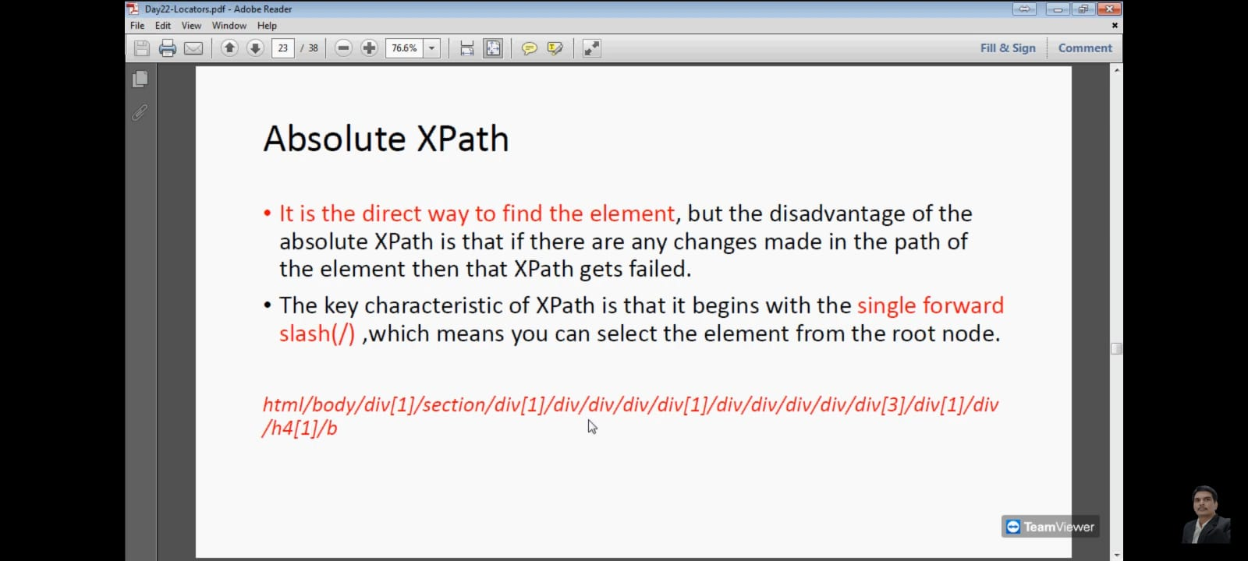

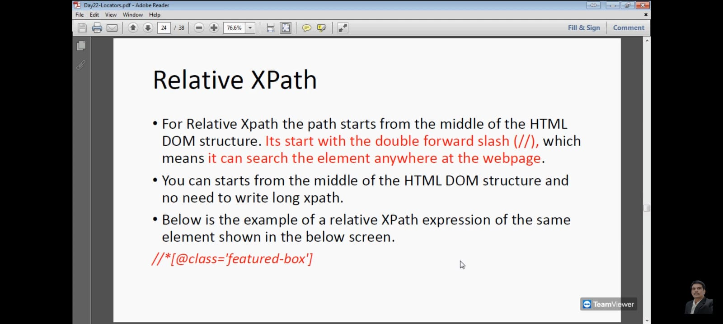

**Basic Xpath:** basic Xpath we use to handle the dynamic and complex elements.

In which we use AND, OR operators.

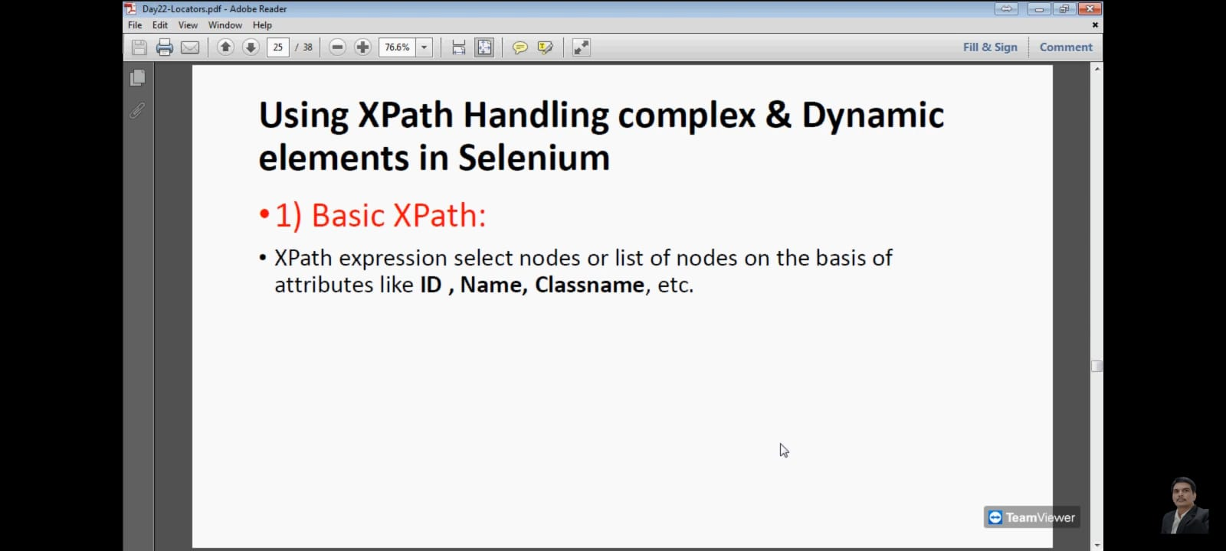

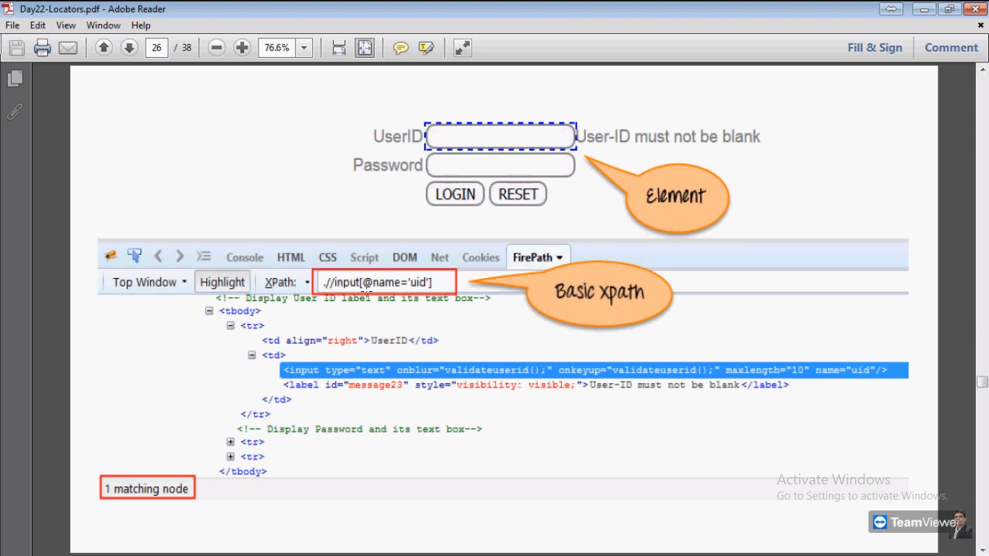

**AND OR Operators in web elements:**

With the help of this operators we can provide multiple attributes in Xpath.

If web elements properties are changing dynamically .in that case we can use these operators.

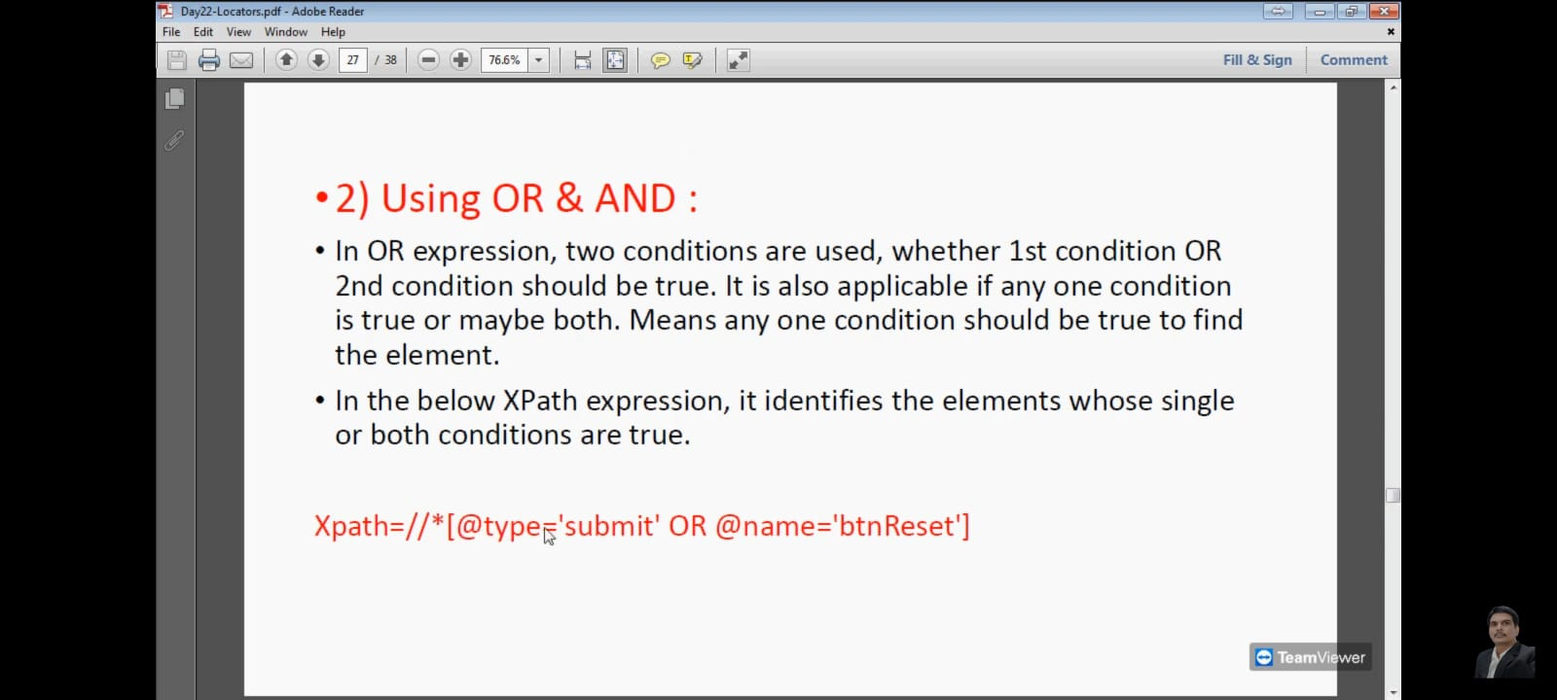

In above Image we have provide two attributes in Xpath. Type and name.

**In below Image we used OR condition :**

In Xpath We can provide different properties of web element. So there we get more surety to locate exact web element.

Sometime properties are changing dynamically like @type= submit001, submit002 , we don’t know what property will be there in runtime. **In that case we use OR, AND operators.**

**OR Operator:**

type= submit OR name= btnLogin. If only one property match then it will select LOGIN button.

In below image name=btnReset is written that is wrong. there should be btnLogin.

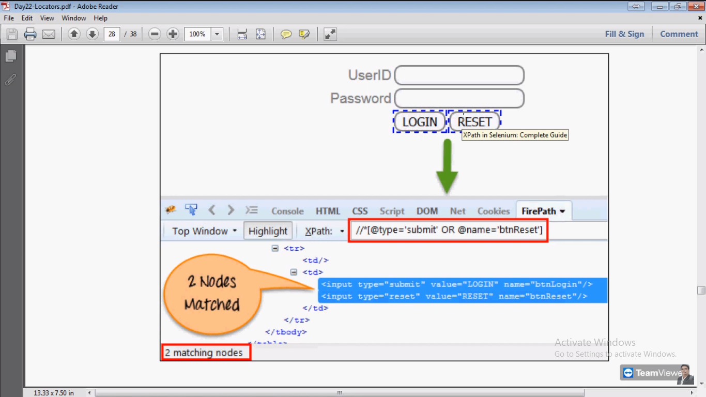

**AND Operator:**

One property in not enough to specify the element then we use AND operator.

For Login Both properties should matches.then only LOGIN button will select.

Sometime properties are changing dynamically like @type= submit001, submit002 , we don’t know what property will be there in runtime. In that situation we use OR , AND operators.

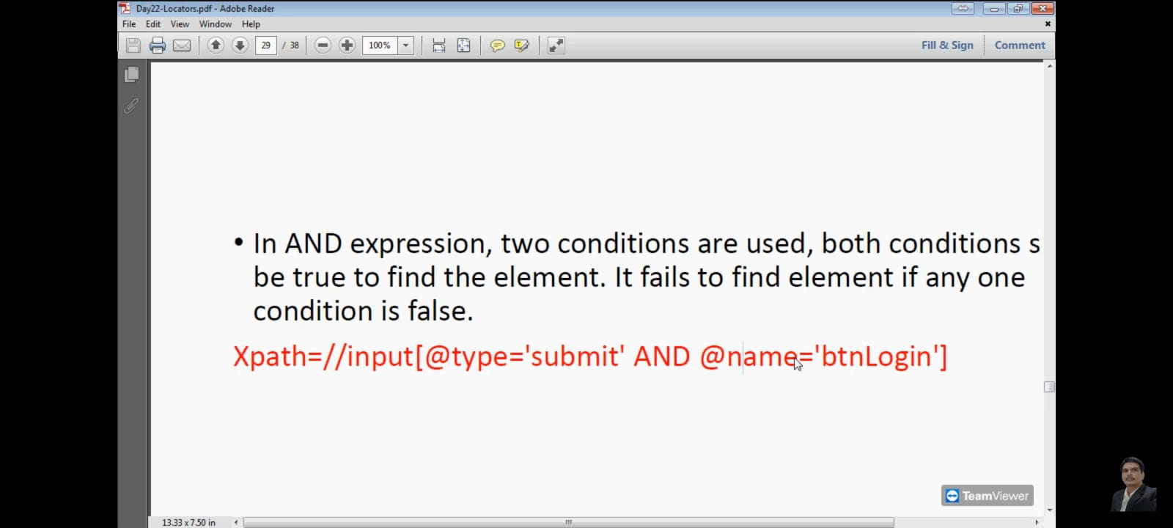

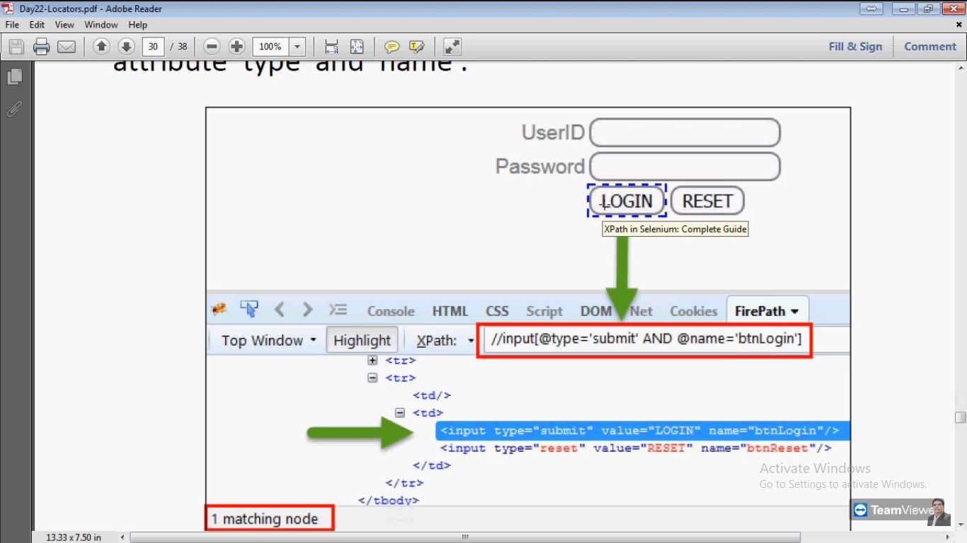

**Another Examples of Xpath:**

**Single Attribute:**

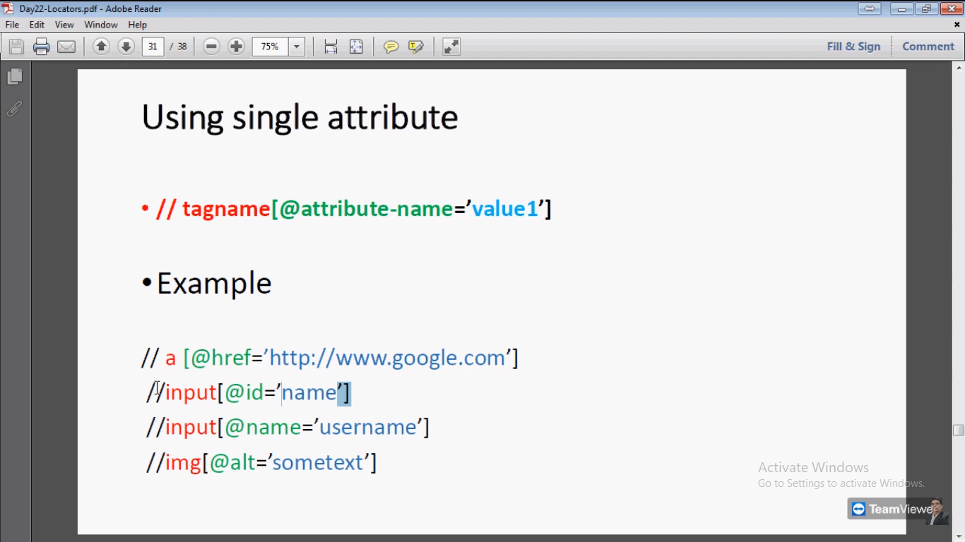

**Note:** img means there is Image. Image tag. For image tag use @alt.

**Multiple Attribute: without using AND, OR.**

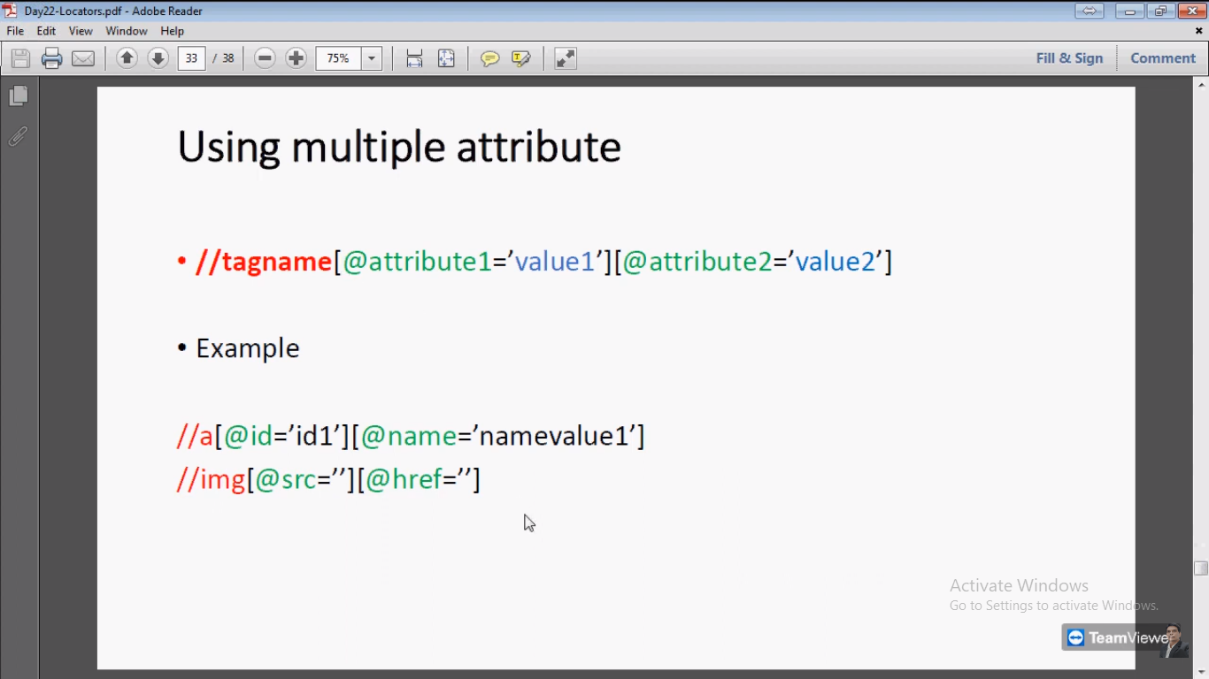

**Xpath Methods:** (when xpath keep on changing then use below methods)

We can handle elements whose properties are dynamically changes.

Web elements properties are changes dynamically. In That case We can use below methods:

**Contains Method:** we know properties values are changes dynamically.

**- Eg.** Suppose we open page that time we get id=email . close and repose then value of id changes to id=email001, again it will change to id=02email again id=btnemail etc

- Eg. Id=email , id =email001, id =02email, id=btnemail.

- In such case we can use Contains method this method will check that email word in id value. **Input[contains(@id,’email’)]** VIMP interview que.

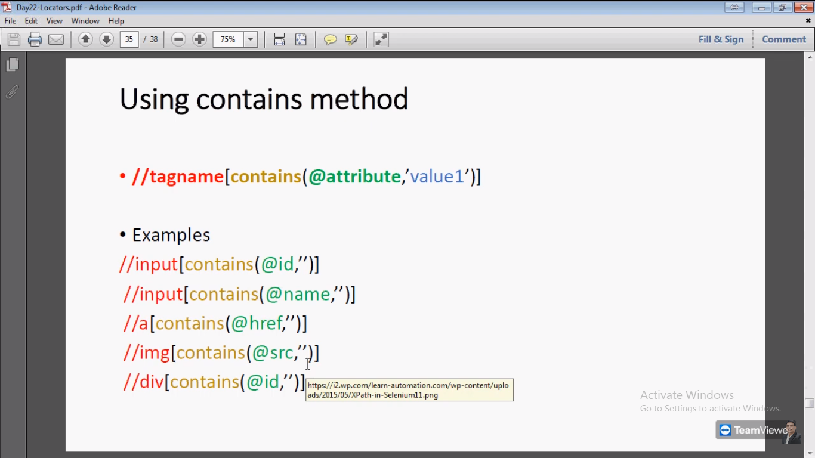

**Start-With method :**

Eg. Name=email001 , name=email-1

**Input[start-with(@id,’email’)] >** our Xpath will match above both names.

**How we will handle dynamically changing properties by using xpath? VIMP**

* We handle by using Contains() and start-with() methods with Xpath.

**\*Data Driven Test Using Excel\***

**Excel:**

**Prerequisites:**

1. Apache POI download
2. Extract this package. Add jars into project
3. <https://archive.apache.org/dist/poi/release/bin/> select binary artifact poi-bin.4.1.1
4. Add jars from **poi-4.1.1** folder, also from **ooxml-lib** folder, also from **lib** folder
5. Steps right click on project> property>java build path>library>class path>add external jars

**Read and write operations:.**

**Excel > workbook > sheet> row > cells**

**Read Operation:**

FileInputStream class >we use for read data from excel file. In which we mention path of excel

XSSFWorkbook class > use for workbook

XSSFSheet class > use for sheet

XSSFCell class > use for cells

**Write:**

FileOutputStream class we use for write data into excel file.

Note: excel has also data types. Select cell > right click> format cell>

Also in java there methods to read value:

-getStringCellValue

-getNumericCellValue

-getBooleanCellValue.